|  |
| --- |
| BUSINESS ANALYSIS REPORT |
|  |
| /Users/supriyatiwari/Downloads/download (1).pngMarch 21  STARBUCKS  Authored by: Moushumi Bhattacharya |

# Business Analysis Project: Starbucks

Business Analysis:

Business Analysis is the research discipline to determine and cater to business problems of an organization by its identifying business needs. These solutions are mostly related to business improvement, policy changes or organizational changes that involves strategic planning. The changes implemented generate value for both the customers as well as the organization.

An analyst, who is given the task to provide business improvement ideas, starts by analyzing the existing business processes thoroughly, and identifying the problems. The organization taken into consideration for this project is Starbucks. The requirement analysis was done by observing the customers at a Starbucks store.

Business Scenario: Starbucks

Corriane walks into the Starbucks outlet, located inside the Las Vegas Blue Diamond Target Store at 12:25 PM. After spending some time around the food display section and deciding what she wants, Corriane walked towards the counter and stood in queue at 12:30 PM. The queue had 4 more customers ahead of her. She waited as the queue slowly moved forward. She re-analyzed her choices for 3 mins and was in front of counter before she could finally decide. The cashier introduced himself as John and asked for her order. Corriane asked for Chonga Bagel, Double Smoked Bacon, Cheddar & Egg Sandwich and Vanilla Latte. John investigated the computer and asked to excuse for a minute as he wasn’t sure if there was any Bagel available. He came back in time and informed Corraine that Bagel will only be available next day and Bacon, Cheddar and Egg Sandwich has run out. He asked Corriane to go for Sausage and Cheddar Breakfast Sandwich instead, nearest possible choice customers go for. Corriane remained confused for a bit but then confirmed her order to be Vanilla Latte Tall and Sausage and Cheddar Breakfast Sandwich. John took her name for the order, put in the new order in the system, and asked if she wanted them to be reheated. Corriane replied she liked her sandwich cold. John went to the display section and took out a Sausage and Cheddar Breakfast sandwich as ordered by Corriane. John kept it beside the payment machine for Corriane to collect once the transaction was complete. John informed Corriane that the total bill was $7.48 and asked her if she would like to pay by cash or card. Corriane said her name and said that she would stick to card. Without further ado, Corriane took her card out, tapped it on the system and completed her transaction. John asked if she needed the receipt copy. Corriane said that she did need it. He handed over the receipt and asked her to wait for the latte. Corriane found a corner for her to sit and wait. She was amazed to find out that it had taken 5 mins for her to place the order. She started eating her sandwich. Meanwhile, John scribbled her name of a tall glass, brewed the latte and kept it on the counter for Corriane to pick. This took another 2 mins. Corriane saw a latte on the counter with her name on it. She went to the counter to pick up her Vanilla Latte. Coriane took a stirrer and a brown sugar sachet. She came back to her table and started enjoying her cold coffee with the sandwich, while scrolling through her ipad. Once she had finished, she left at 01:25 PM.

Process: Key Information Identified

* Store Location: Target, Las Vegas Blue Diamond
* Stakeholders: Corriane (Customer), John (Store Employee)
* Products: Vanilla Latte Tall, Sausage and Cheddar Breakfast Sandwich
* Infrastructure: Scanner, Computer, Card Reader, Receipt Printer
* Timeline: Entered at 12:25 PM. Checkout ~ 12.40 PM. Left store at 1.25 PM

Process: Understand Goals

|  |  |  |
| --- | --- | --- |
|  | Customer | Store Employee |
| Tasks | Enter the store  Decide what to order  Stand in queue  Place order  Pay for order  Take Receipt  Wait for items  Pick up items  Have the items  Exit store | Help customers by placing order  Scan items  Suggest items to order as replacements  Place order  Print receipt |
| Goal | Quick order processing | Ensure that customers get the items and sizes they need and make payment. Provide seamless customer experience |

Process: Swim Lane Diagram

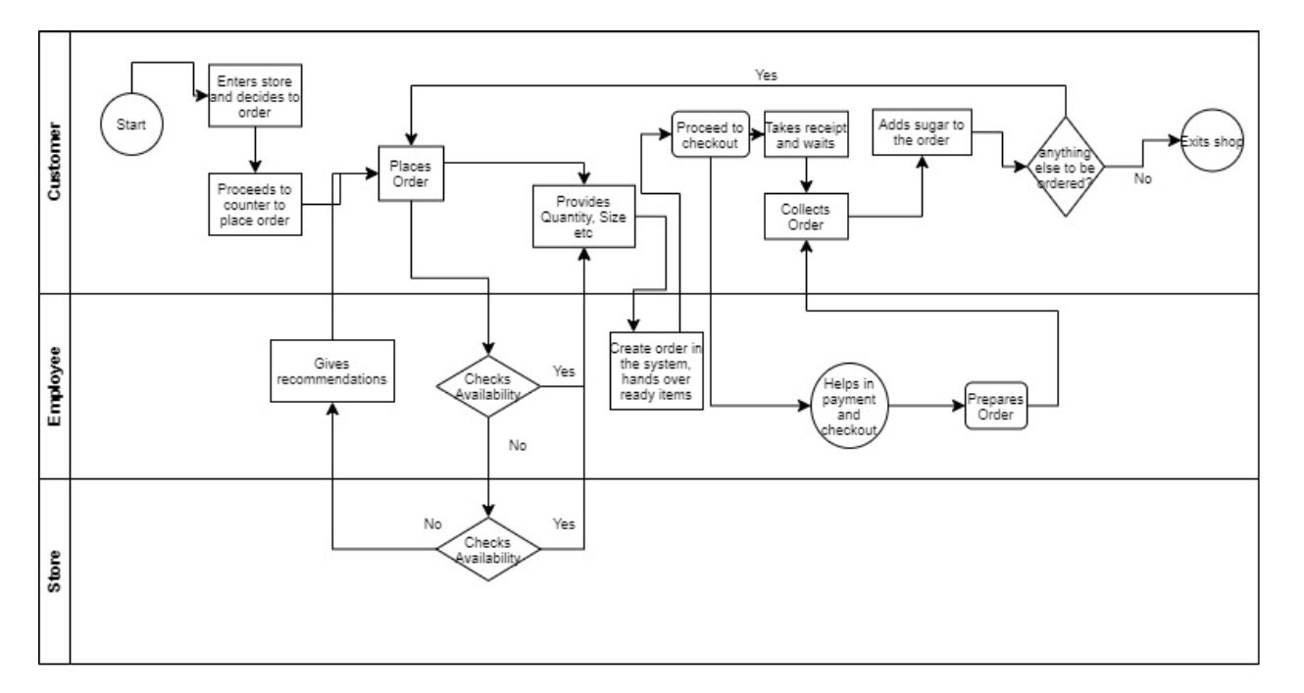

Process: Business Questions

1. Highest and lowest demand product
2. Find the total amount paid by customer for every order
3. Compute the total no of units ordered in every order number
4. Highest priced product
5. What are the users having other than Coffee
6. Products ordered by customers: Most ordered items & Least Ordered items
7. Average sale of the store (per day/per week/per month)
8. Average bill value per order
9. Orders having Bill Value higher than Avg Bill Value and type of Payment method used
10. Top 5 transactions made by customers and their payment modes
11. Who are the customers who pay more than Average Bill Value
12. Amount paid by customer for every order
13. Specific time of the day when specific items are being ordered
14. More preferred transaction method- Card or Cash.
15. Calculate the total revenue collected from various modes of payment
16. Total Revenue made weekly for every month
17. Total revenue made in the two months January and February
18. No of Orders placed and Total collection made during the busiest time frame

Data: Transaction Details



Data: Type of data

It is random business data of Starbucks for the sales transactions that happen every day with their customers. It is a random set of data from 6th January 2020 to 20th February 2020. This data will be used henceforth in analysis for this project. The data exists of orders placed by customers including details of order number, date of order, time of order, name of customer, product identifier, product description, product quantity, product price and transaction details.

Data: Normalization Technique

The data collected by observing customer at the Starbucks store is denormalized and useful only for querying. To load this data into database table and create a schema, data normalization is needed. In this section of the report we will create 3NF forms of entity table from the retrieved dataset.

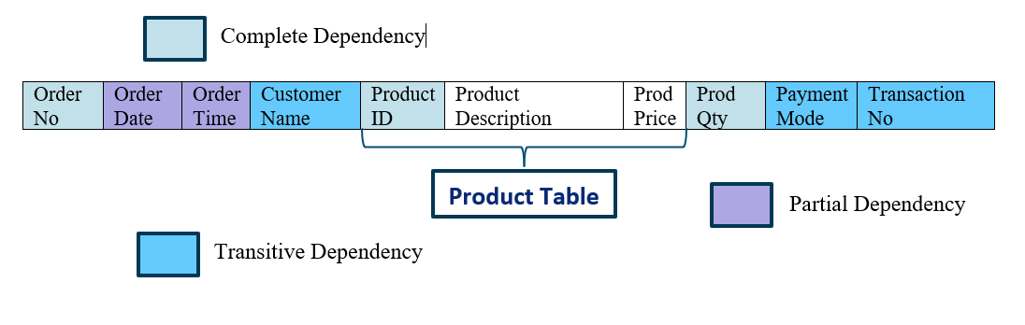

Table 1 NF



Customer Order:



Customer Transaction:

Two new cols added

Product Table:



Order Lines:



Data: Entities & Attributes

* Order (customer_order): Order No, Order Date, Order Time and Transaction No

Primary Key: Order No

Foreign Key: Transaction No

* Customer (customer_transaction): Transaction No, Customer Name, Payment Method, Payment ID

Primary Key: Transaction No

* Order Lines: Order No, Prod ID, Prod Qty

Candidate Key: Order No, Prod ID

Foreign Key1: Order No

Foreign Key2: Prod ID

* Product: Prod ID, Prod Description, Prod Price

Primary Key: Prod ID

MySQL: Load Data into Tables

Create entity tables Product, Customer Transaction and Customer Order

create table product

(

prod_id varchar(50) not null,

prod_desc char(100) not null ,

prod_price float(5,2) not null,

constraint prodid primary key (prod_id)

);

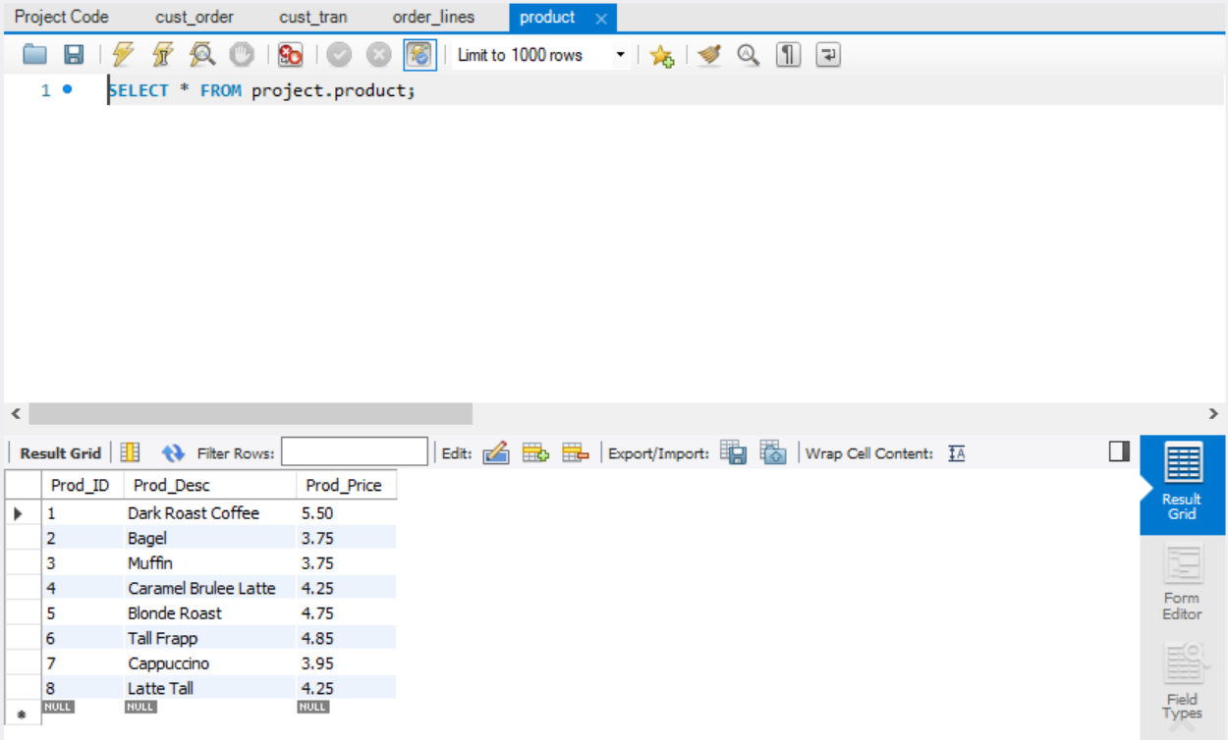

create table cust_tran

(

tran_id varchar(50) not null,

cust_name varchar(20) not null,

payment_meth char(20) not null,

payment_id integer(10),

amount numeric(8,2) not null,

constraint tranid primary key (tran_id)

);

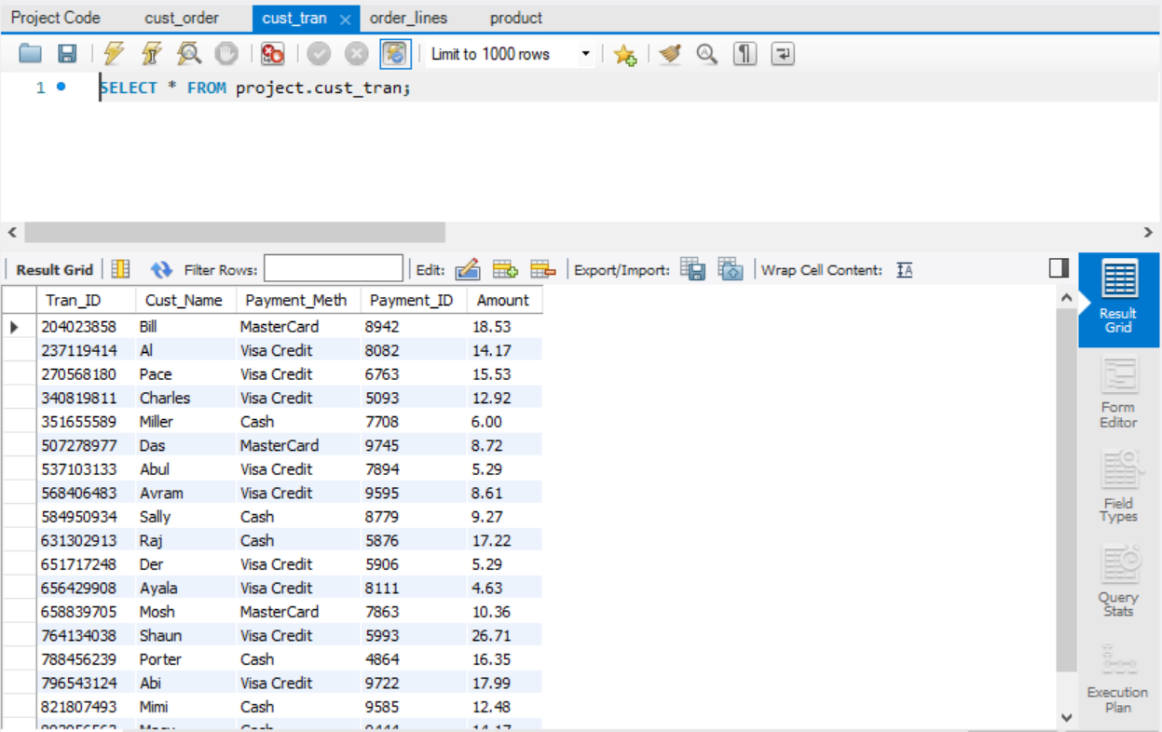

create table cust_order

(

order_no varchar(50) not null,

order_dt date not null,

order_tm time not null,

tran_id varchar(50) not null,

constraint fk1 foreign key (tran_id) references cust_tran(tran_id),

constraint pkorderno primary key (order_no)

);

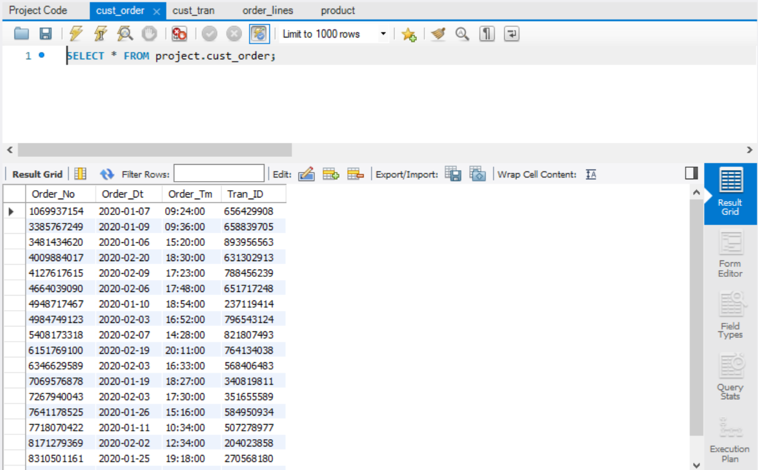

Create order lines table

create table order_lines

(

order_no varchar(50) not null,

prod_id varchar(50) not null,

prod_qty int4 not null,

constraint fk2 foreign key (order_no) references cust_order(order_no),

constraint fk3 foreign key (prod_id) references product(prod_id),

constraint pklines primary key (order_no, prod_id)

);

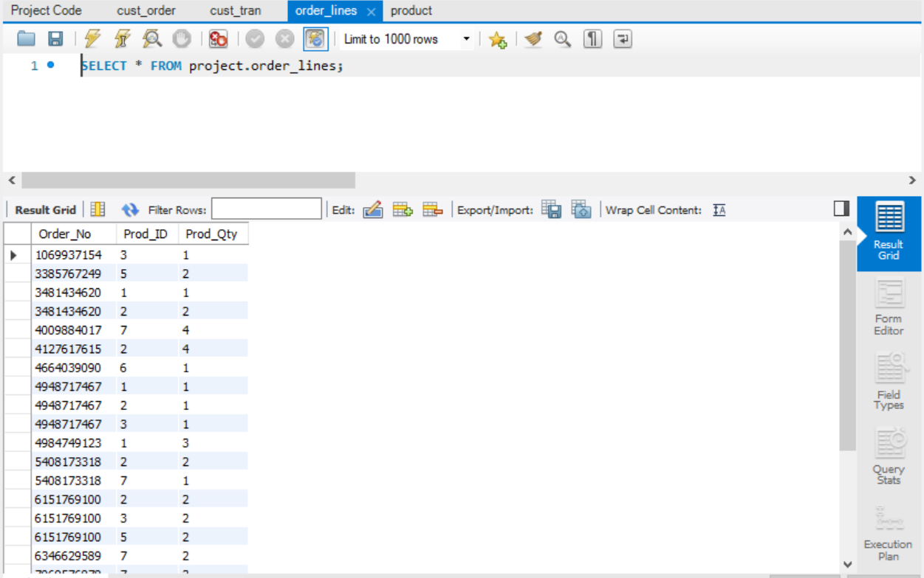

Entity Relationship Diagram

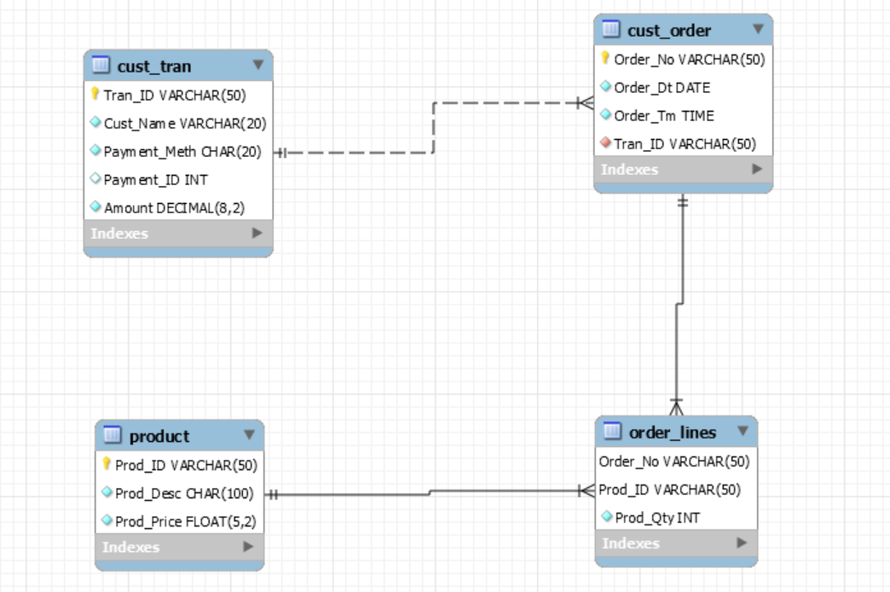

Data Analysis: SQL Queries

1. Handling business scenario questions with SQL Queries without Joins
2. What is max priced product in the data set?

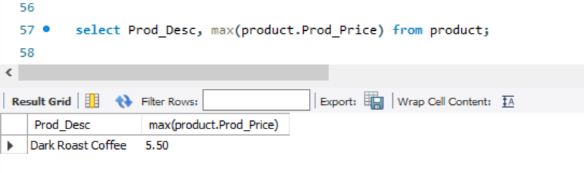

1. Which customer pays the maximum amount and how much?

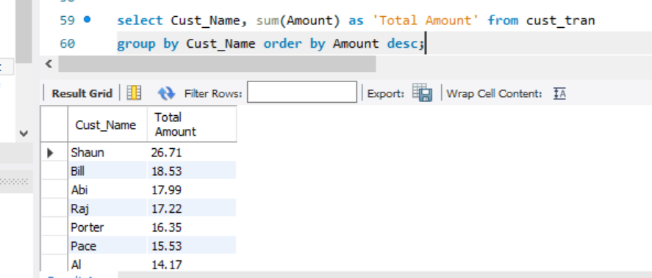

1. 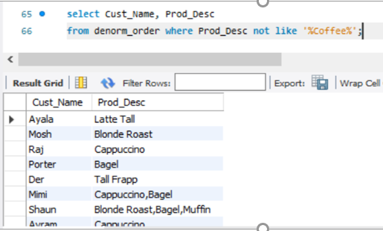Customers who ordered Coffee and customers who did not order coffee

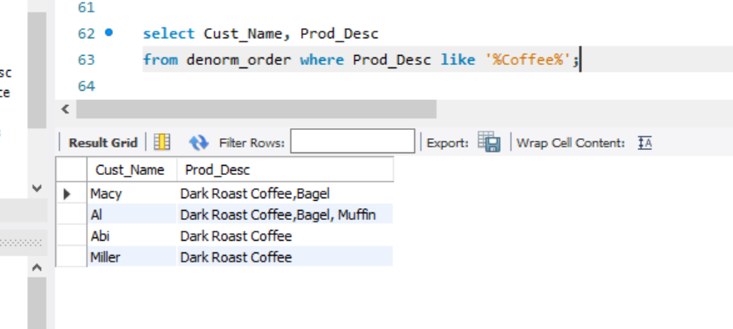

1. What is the average bill value at the store?

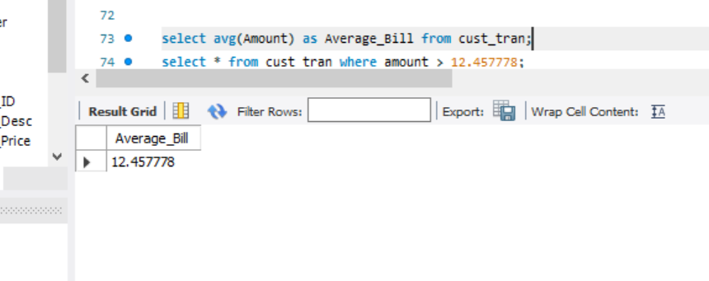

1. Calculate the total revenue collected from various modes of payment

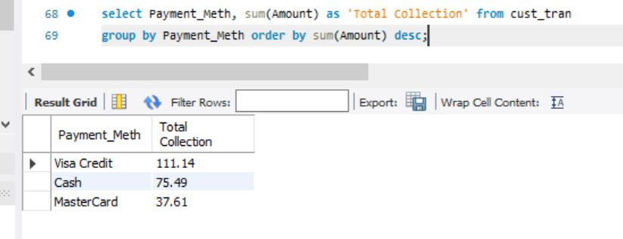

1. Preferred mode of Transaction

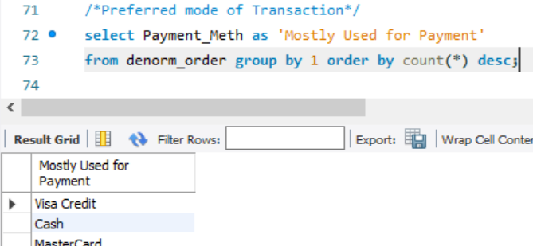

1. Who are the customers who pay more than Average Bill Value

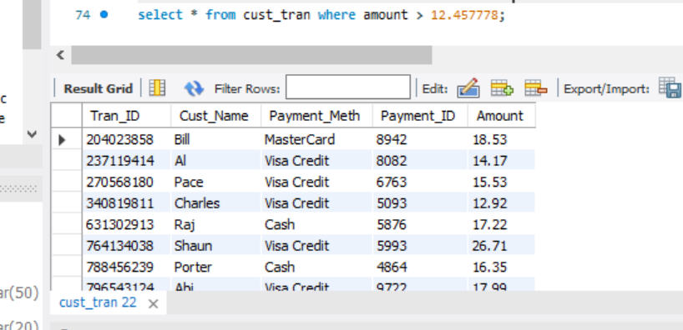

1. Compute the total no of units ordered in every order number

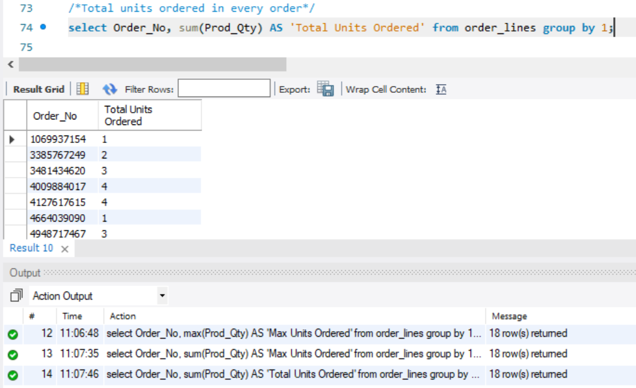

1. Handling business scenario questions with SQL queries with joins
2. Find the total amount paid by customer for every order

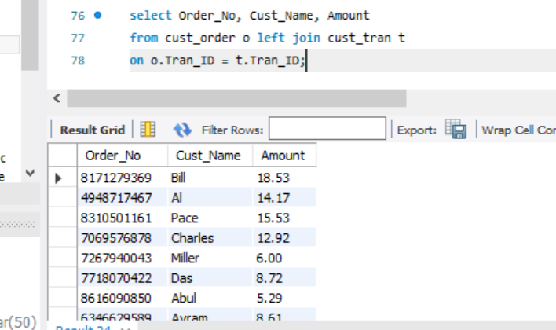

1. Top 5 transactions made by customers and their payment mode

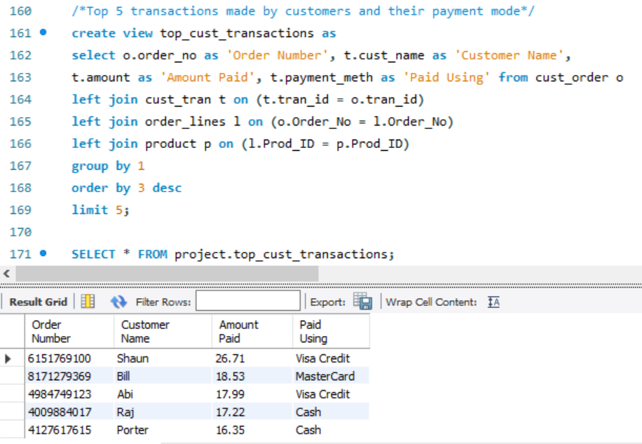

1. Most ordered items in the store

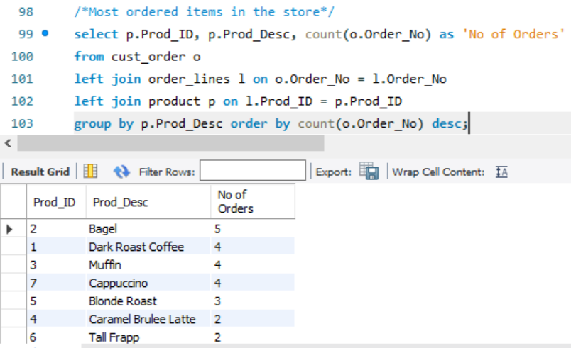

1. Least ordered item in the store

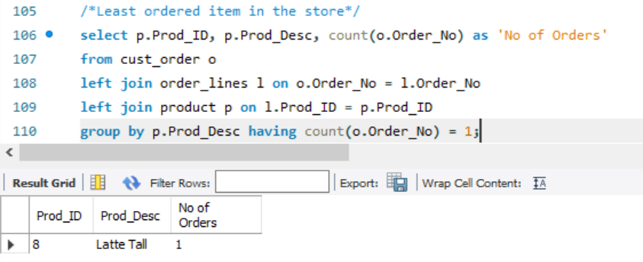

1. Time during the day when most ordered item (*Bagel, Prod_ID = 2*) was ordered

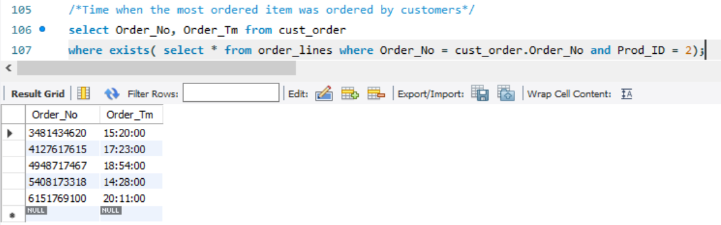

1. Time during the day when least order item (Latte Tall, Prod_ID = 8) was ordered

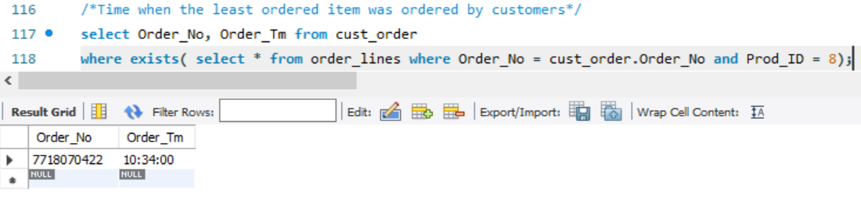

1. Orders having Bill Value higher than Avg Bill Value and type of Payment method used

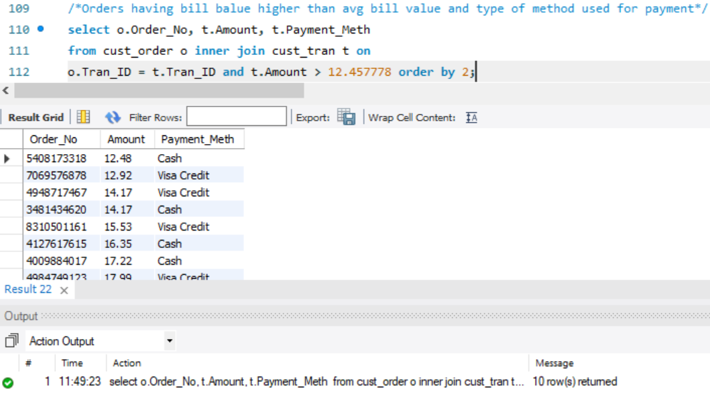

1. No of Orders placed and Total collection made during the busiest time frame

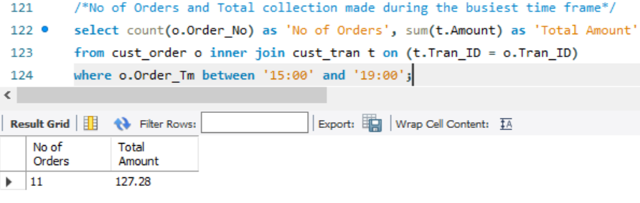

1. Products ordered by customers

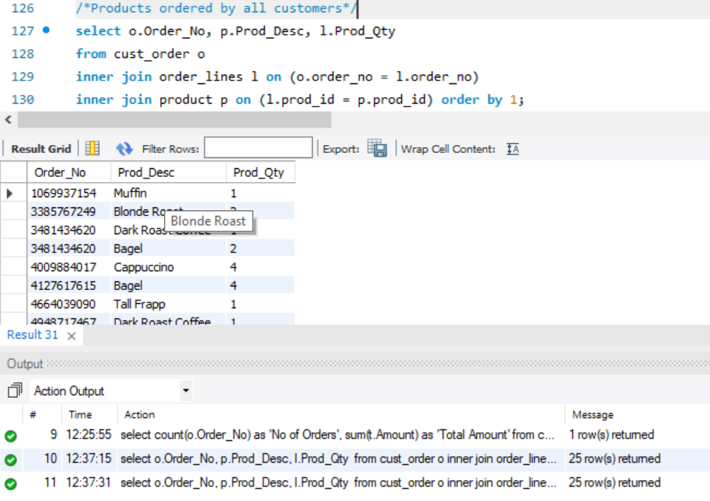

1. Total revenue made in the two months January and February

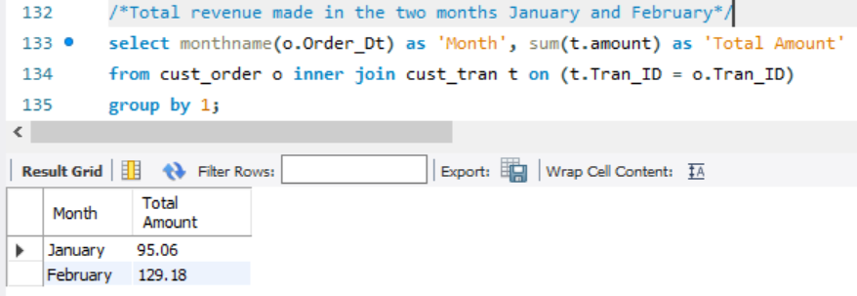

1. Total Revenue made weekly for every month

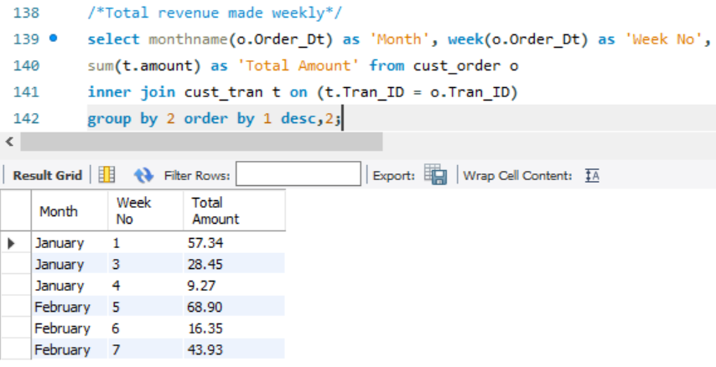

1. Views
   1. Create a view of Top 5 products ordered and by how many customer

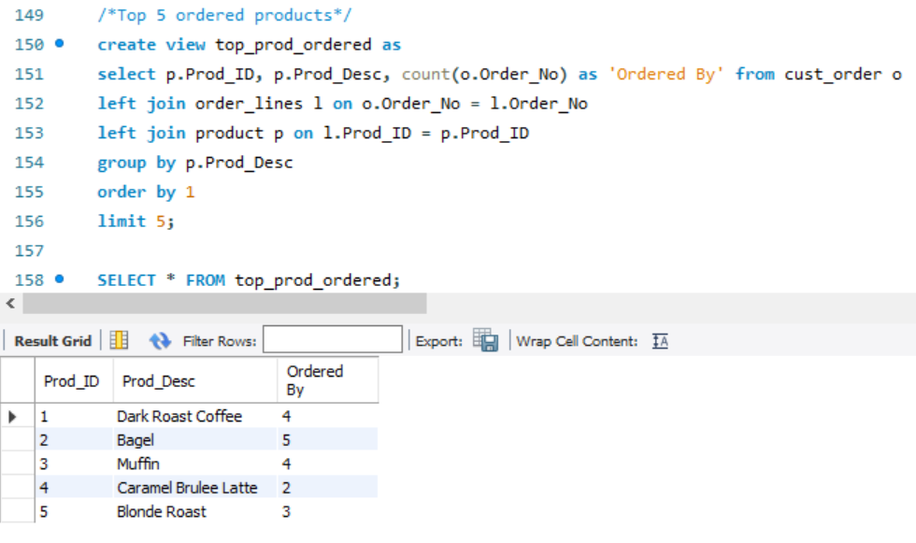

Data Analysis: Advanced SQL Queries

Using advanced SQL queries to answer some more business questions

Using Case Statement: Make of list of who ordered coffee and who did not, using case statement

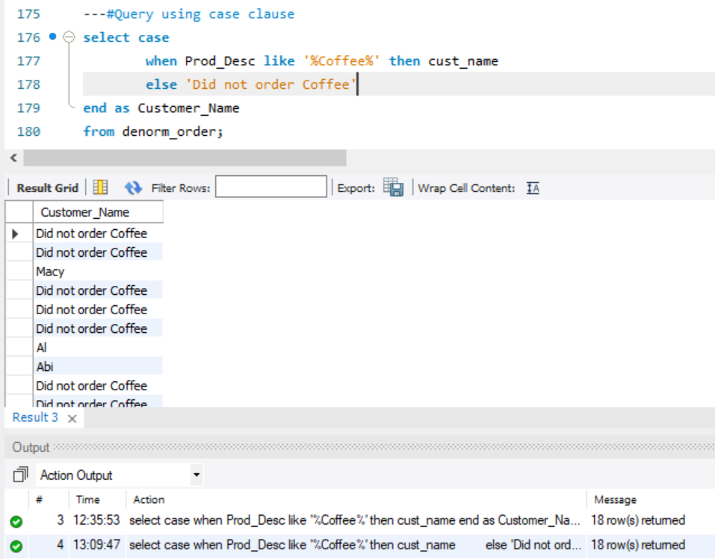

Using Union: Collate a list of highest paid customers (>$17) and lowest paid customers (<$6)

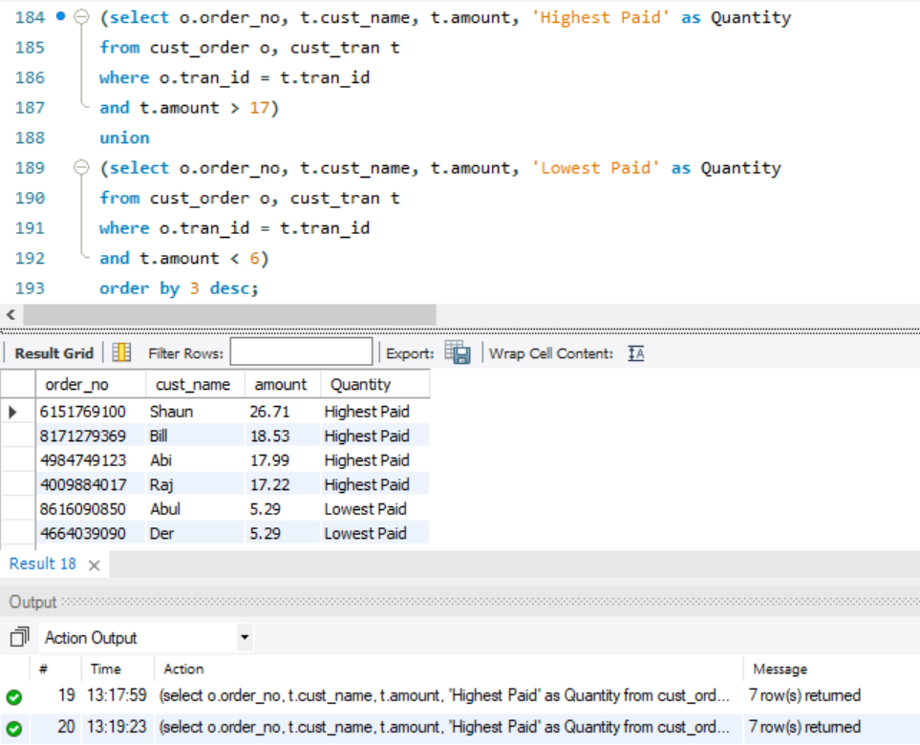

Using Rank: Rank customers based on the total qty of products ordered by them

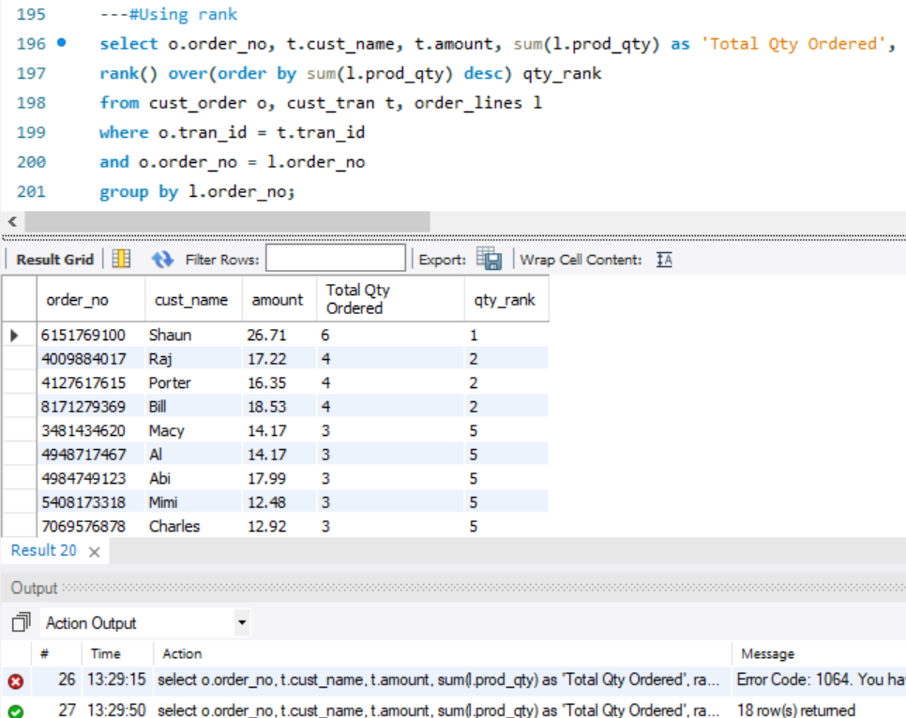

Implement a trigger on a table

Trigger: Customer Insert Trigger for any customer insert on cust_tran

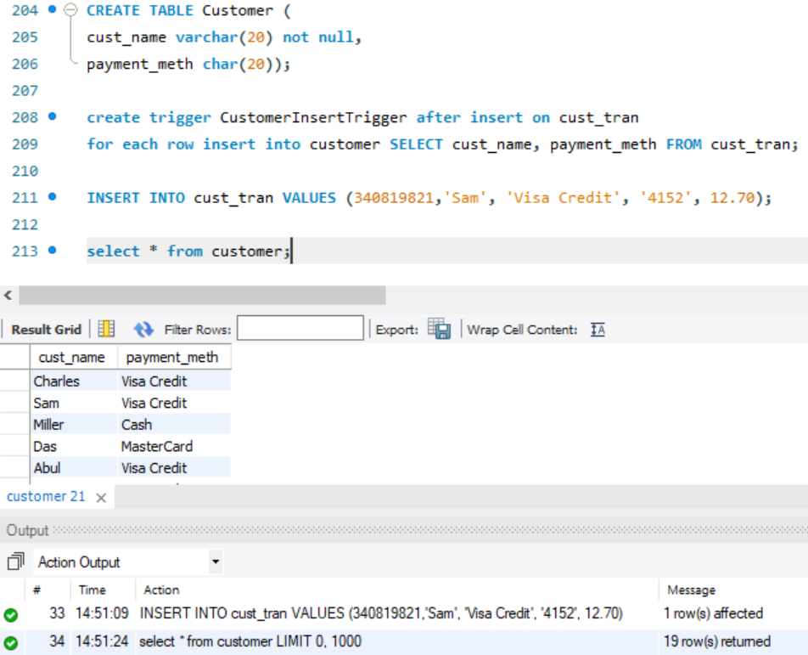

Stored Procedure: Create stored procedure to filter payment method, amount and no of items ordered by customer with name starting with ‘A’ or ‘M’

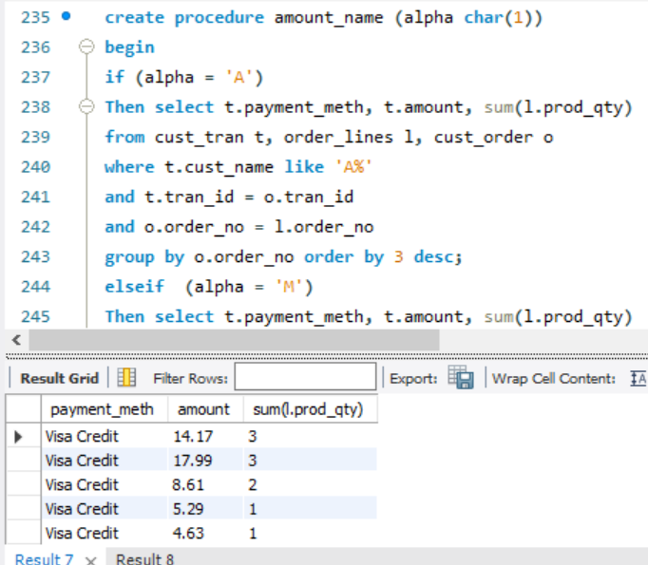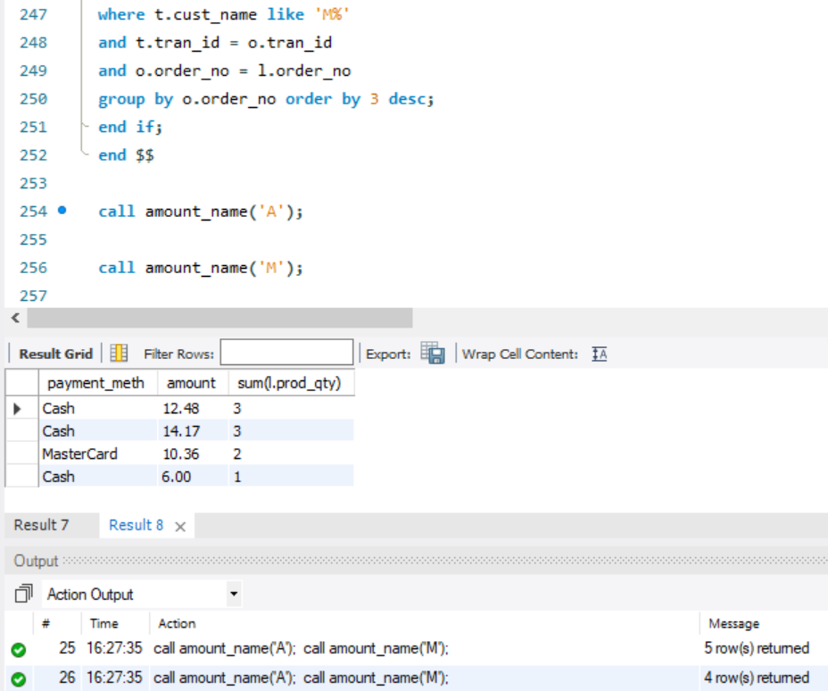

Data Visualization: Tableau

1. Tableau chart to see average revenue from each product

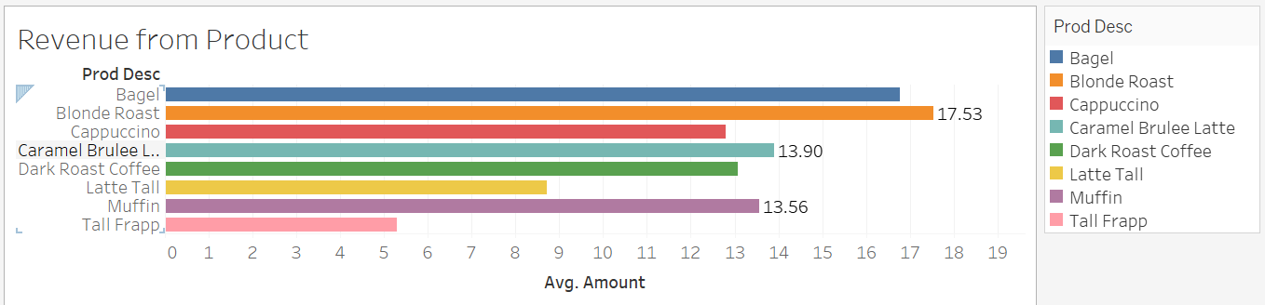

1. Product Quantity ordered by each Customer

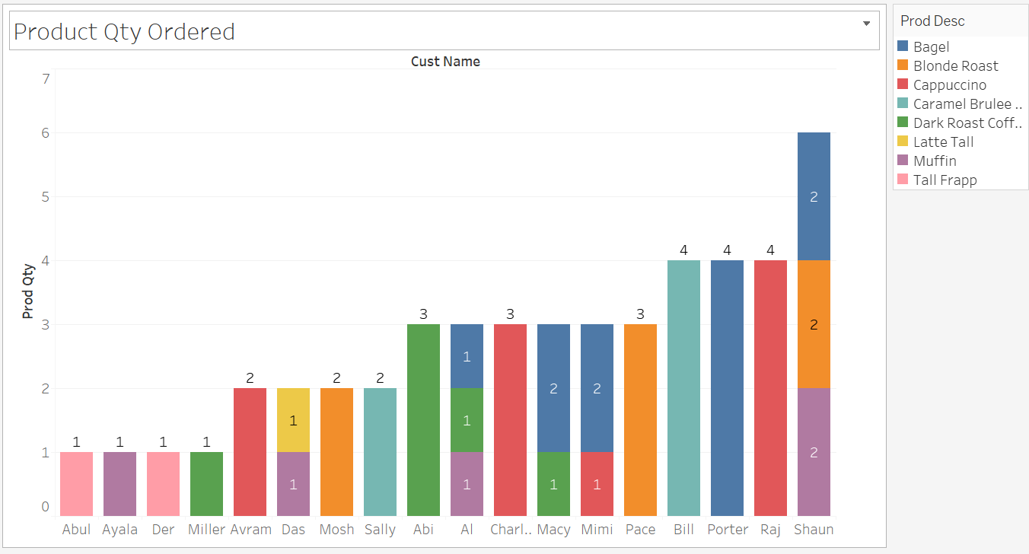

1. Average amount collected for each payment method

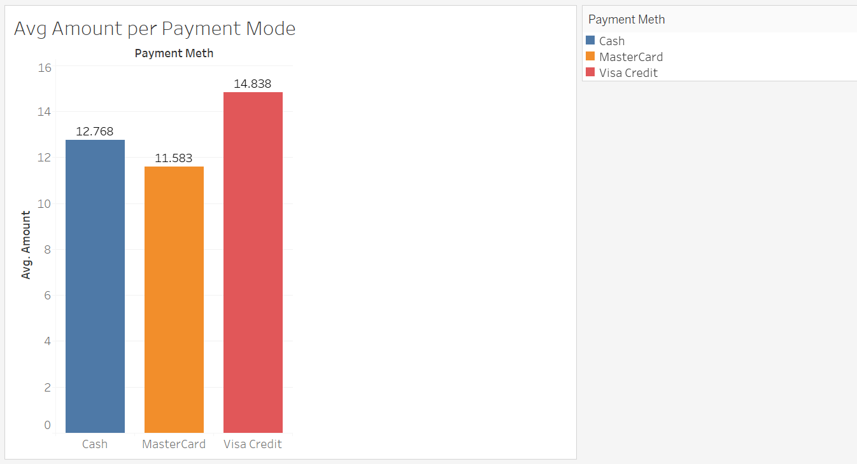

1. Busiest hour of the day based on no of products and quantity

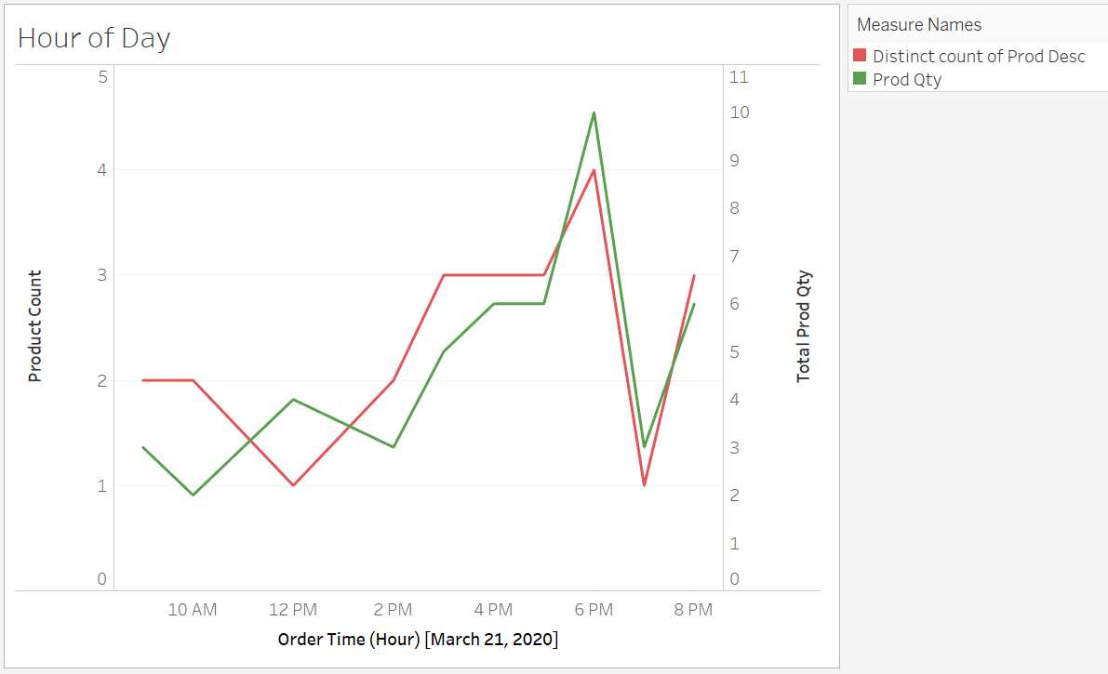

Data Visualization: Dashboard

During the busiest hour of the day: -

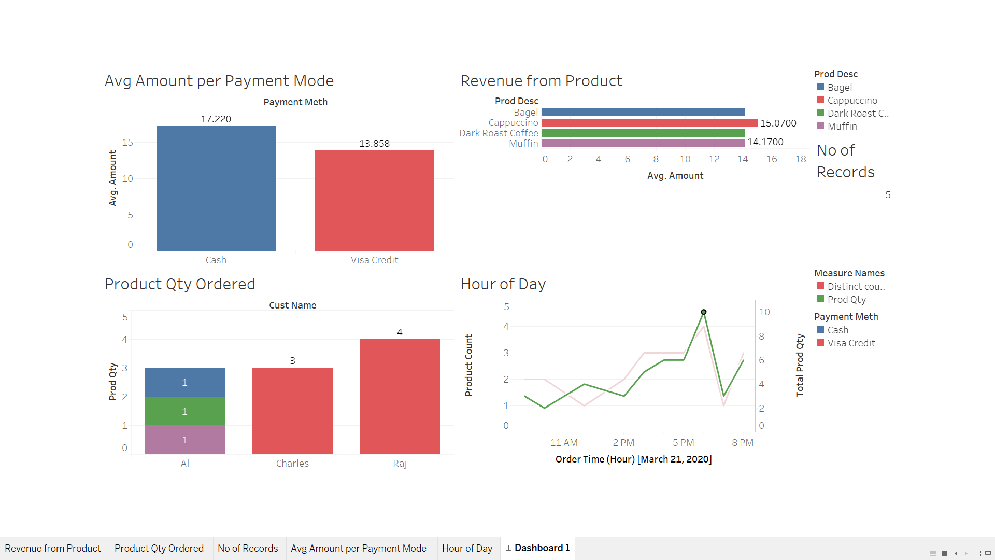

Conclusion:

During this analysis, these were some key findings:

1. There is rise of customer footfall from 3-6pm when the outlet attracts the maximum revenue during the day.
2. The most customer friendly mode of payment is Visa Credit Card
3. Though coffee is the star product for Starbucks, the most ordered item is Bagel and Dark Roast coffee is a favorite.
4. There is sharp fall in customer footfall from 6-8pm. This maybe because of home returning office crowd.
5. On average, a customer orders around 3 items in an order.

This project has been engaging as it helped to learn the use of data and making data base tables. It helped in making conclusions about various business questions and the analysis results will help solve various business needs. The data visualization helped further with viewing changes in data according to time of the day and the variation in amount and quantity ordered.